HACKERRANK
Conditional Statements in C | HackerRank
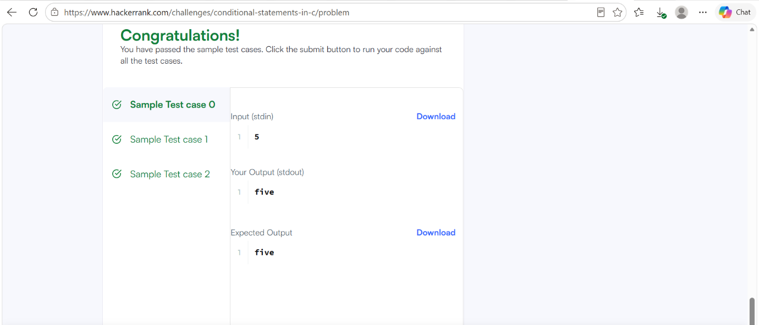

CODE
#include <stdio.h>
int main() {
int n;
scanf("%d", &n);
if (n >= 1 && n <= 9) {
char *words[] = {
"one", "two", "three", "four", "five",
"six", "seven", "eight", "nine"
};
printf("%s\n", words[n - 1]);
}
else {
printf("Greater than 9\n");
}
return 0;
}

